|  |  |
| --- | --- |
| **Names** | **ID** |
| **Hadi Mohammad Abboud** | **202301783** |
| **Mohammad Omar Terro** | **202301698** |
| **Bachar Al Zein** | **202303333** |
| **Abbas Al Ghizzawi** | **202306076** |
| **Mohammad Yassine** | **202304510** |

**Project Tittle: LEVEL UP**

**LEVEL UP**

by

**GROUP 6**

**Project**

Submitted in Partial Fulfillment of the Requirements for the Degree of Bachelor in Computer Engineering

Department of Electrical & Computer Engineering

Faculty of Engineering

**Supervised by**

**Prof. /Dr Iman Haidar**

Position and title

Year 3



**The Project Defense Committee for Group 6 Certifies that this is the approved version of the following project**

**LEVEL UP**

**APPROVED BY:**

**Supervisor Signature:**

(Name typed under the line)

**Co-supervisor Signature:**

(Name typed under the line)

**Examiner Signature**:

(Name typed under the line)

**Examiner Signature:**

(Name typed under the line)

Contents

List of Figures 5

List of Tables 6

Project Description 7

Project Overview 7

Objectives 7

Background 8

Literature Review 8

Applications 9

Alternative Designs 9

Project Planning 10

Constraints 10

Project Issues 10

Team Members Tasks 11

Ethical Issues 11

Software Model Process 11

Feasibility Study 12

Tools/Technology 12

Standards 12

Milestones 13

Requirements 13

Use Cases 13

Functional Requirements 14

Data Requirements 14

Non-Functional Requirements 15

Design 17

Class Diagrams 17

Dynamic Model 18

Subsystem Decomposition 18

Hardware / software mapping **Error! Bookmark not defined.**

User Interface **Error! Bookmark not defined.**

Test Plans 20

Implementation 22

Results Evaluation 27

Conclusion 28

Summary 28

Novelty **Error! Bookmark not defined.**

Integrity and Values **Error! Bookmark not defined.**

Future Work 28

References / Bibliography 29

Appendix 31

# List of Figures

Figure 1 - Sample Image of a Survey Dive Boat 11

# List of Tables

Table 1- Sample Table of Survey Dive Activity 11

# Project Description

## Project Overview

The project at hand is a web platform where users connect with certified personal trainers, nutritionists, and therapists in order to achieve holistic health. The web platform strives to enable users to book sessions; keep track of their progress; and receive personalized guidance, while providing professionals with a means to expand their clientele. Another facility on the platform is that of a community whereby users can post about problems they may be experiencing, connect with other users, partake in activities, and support a cause by either donating funds or joining in donation campaigns. By merging physical fitness, nutritional support, mental health services, and community engagement, such a platform will be addressing the demand for holistic health care solutions.

The project is a revolutionary web platform that connects users to certified personal trainers, nutritionists, and therapists to promote holistic health. It provides seamless experience in booking sessions, progress tracking, and personalized guidance for users and also serves as a base for professionals to further develop their clientele. The platform further provides a community where individuals can express their ills, meet other individuals, participate in activities, and contribute to charitable causes through donations and campaigns. By incorporating fitness, nutrition, mental health services, and community activity, the project caters to the increasingly demanding need for faster and comprehensive access to holistic health solutions. The platform empowers users to take their health goals to the next level and surrounds them with supportive engaged community.

## Objectives

Provide users with easy access to certified health professionals.

Offer a holistic approach to health by combining physical fitness, nutrition, and mental well-being services.

Create a user-friendly platform with tools for scheduling, progress tracking, and community support.

Build a trusted ecosystem where professionals can expand their reach, and users can achieve their health goals.

Foster a supportive community where users can connect, share experiences, and participate in charitable activities.

## Background

Addressed are the problems associated with the health and wellness industry that are growing very enthused. Physical fitness, balanced nutrition, and mental well-being are a few areas that an increasing number of people have started to appreciate. But still, when it comes to fulfilling health goals, they often come across resources that are not, say, reliable, or easily accessible. These projects bridge that gap in connecting individuals to certified professionals on a centralized platform where people can get personalized guidance toward improving their health. It can even be the community feature for social support, activity participation, and contribution toward causes. Application of software is definitely a very important one for advanced living under very common conditions such as fast-paced lives with mobility, trust, and community involvement.

With the health and wellbeing industry booming, awareness of physical fitness, nutrition, and mental wellbeing is on the rise. However, searching for comprehensive, affordable, and accessible resources is a challenge for most people. This project aims to fill the gap by providing one single platform where one can get in touch with certified professionals who will give detailed instructions on the treatment of the client's health with an emphasis on personal concerns. The platform helps to develop a community for social support, activities, and charity. The importance of software applications in the creation of healthy living cannot be overemphasized, especially since modern living has promoted convenience, trust, and community involvement.

## Literature Review

This study will review the existing online platforms that can provide holistic health for its user - physical fitness, nutrition, mental well-being, and community engagement. Some of the platforms in the world include: Well, Me Right, Burnalong, and Practice Better, which all offer individualized health services, on-demand classes, and practice management tools. Though these platforms promise convenience, access, and community support, they also have their setbacks such as excessive dependability on the Internet and varying levels of service across their offerings.

Reem El Khazen's holistic nutrition coaching, The Healing Sisters Holistic Center, and Chinese Medicine - Beirut serve wellness solutions culturally relevant to Lebanon; these often focus on a specific niche and lack overall integration of aspects that be included within holistic health.

In this respect, the opportunity is to build a seamless web interface that could provide personalized services, community engagement and educative materials. Such a web platform would be able to meet the growing demand for credible, accessible, and comprehensive healthcare solutions in Lebanon.

## Applications

Level Up web platform can be built by learning from other platforms that link users with certified personal trainers, nutritionists, therapists, and community support. Some key features include:  
  
1. Custom Health Services: Offering personalized training, nutrition, and mental health plans that fit each person's needs.  
  
2. All-in-One Scheduling and Tracking: Giving users tools to book sessions and keep an eye on their progress as time goes by.  
  
3. Community Interaction: Setting up forums and groups where users can swap stories, team up on projects, and back charitable causes.  
  
4. Learning Materials: Providing articles, videos, and workshops about various health topics to give users more knowledge and power

## Alternative Designs

Consequently, the platform can be designed with the following common approaches to accommodate the users' requirements in Lebanon:  
  
**1)Mobile First:** The prime app interface is to be designed as most people in Lebanon are consumers of services through smartphones.  
**2)Modular Design:** This implies that users will select those special services that may include fitness, nutrition, or mental health depending on their individual needs.  
**3)Telehealth Integration:** To conduct online consultations so that health professionals may deliver these services remotely, regardless of the given location.  
**4)AI Suggestion:** The artificial intelligence component helps to provide personalized content and service recommendations based on user preferences and behavior.  
The platform should be multilingual and offer Arabic, English, and French to serve respectably among the Lebanese population.  
These approaches will ensure the establishment of a well-balanced health platform which is both flexible and accessible in nature and meets today's local and modern needs.

# Project Planning

## Constraints

1. **Implementation Environment of the Current System**

The platform is being developed using Laravel 11 as the backend framework, with MySQL as the database for data storage. The frontend will use Blade templates alongside Vue.js for dynamic interactions.

1. **Partner or Collaborative Applications**

The platform will integrate with third-party applications such as:

* -Payment Processors: Stripe, PayPal for handling transactions.
* -Video Conferencing Tools: Zoom, Google Meet for telehealth consultations.
* -Authentication Services: Social login (Google, Facebook) for user convenience.

1. **Off-the-shelf Software**

To accelerate development, LEVEL UP will utilize:

* Stripe/PayPal APIs for payment processing.
* Zoom/Google Meet APIs for video consultations.
* Laravel Packages for authentication, scheduling, and role-based access control.

1. **Anticipated Workplace Environment**

The platform will be a web-based application, optimized for both desktop and mobile use, ensuring smooth access via desktops, smartphones and tablets

1. **Schedule Constraints**

The project timeline is set to 12 weeks. So Development will be divided into phases, starting with an MVP (Minimum Viable Product) that includes core features like booking and authentication. Later phases will add community engagement, donations, and AI-powered recommendations. Additionally, scheduling must account for lab availability and coordination among group members.

1. **Budget Constraints**

The project has a limited initial budget, focusing on essential features first. Future monetization (such as subscription models or commission on transactions) can help sustain the platform. Additional funding may be required for AI development, video call integration, and scaling infrastructure.

## Project Issues

Issues that have been raised and do not yet have a conclusion:

* Scaling Challenges: How to ensure smooth performance with increasing users.
* User Trust: Verifying professionals while keeping the process efficient.
* Moderation Policies: How to handle content moderation and user reports effectively.

## Migration to the new product

Migration to the New Product:

Since the platform is being built from scratch, there is no need to migrate old data. The main focus will be on making it easy for professionals and users to sign up. A smooth registration and verification process will help ensure more people join and use the platform.

## Team Members Tasks

**Manager:**

* Oversees project execution and ensures deadlines are met.
* Manages team communication and coordination.
* Makes strategic decisions on platform growth and future development.

**Designer:**

* Responsible for UI/UX design, ensuring an intuitive and accessible user experience.
* Develops wireframes, prototypes, and brand identity.
* Ensures a responsive design approach.

**Developer:**

* Builds and maintains the Laravel backend and database.
* Implements frontend features using Blade/Vue.js.
* Integrates APIs for payments, video calls, and authentication.
* Ensures security best practices and system scalability.

## Ethical Issues

Privacy Concerns: Ensuring user data, including medical-related consultations, is protected.

Transparency: Clearly displaying professional credentials and ratings to maintain trust.

Fair Access:Ensuring everyone is treated equally and preventing any unfair treatment in the community.

## Software Model Process

## 

We'll build and test features step by step, releasing small updates instead of waiting to launch everything at once. User feedback will help us improve along the way.

## Feasibility Study

## 

**Technical Feasibility:**

* Laravel 11 ensures a robust backend structure.
* Payment and video conferencing integrations are widely supported.
* Scalable cloud hosting options (AWS, DigitalOcean) allow future expansion.

**Operational Feasibility:**

* The platform is designed to be user-friendly, with an intuitive booking system and a verified professional directory.
* Admins will manually approve professionals to ensure service quality.

**Economic Feasibility:**

* Initial costs will cover hosting, development, and integrations.
* Future monetization can come from commission-based bookings, premium features, or sponsorships.

## Tools/Technology

* Backend: Laravel 11, MySQL/PostgreSQL.
* Frontend: Blade, Vue.js (if required).
* Payment Integration: Stripe, PayPal, Wish, Western Union(OMT).
* Video Call Integration: Zoom, Google Meet APIs.
* Hosting: AWS, DigitalOcean, or shared hosting.

## Standards

* Security: User data will be protected with encryption and follow privacy rules (GDPR).
* Development: The code will follow PHP best practices (PSR-4) to keep it clean and organized.
* Accessibility: The platform will be easy to use for everyone.

## Milestones

**12-Week Development Plan**

* **Phase 1 - Authentication (Weeks 1-2)**

Set up Laravel authentication (registration & login)

Implement user roles (users & professionals)

Develop admin approval system for professionals

Create password reset & security features

Test authentication system

* **Phase 2 - Booking System (Weeks 3-5)**

Set up professional schedules (available time slots)

Develop appointment booking system

Implement professional confirmation/cancellation

Add 48-hour cancellation & rescheduling policy

Test booking functionality

* **Phase 3 - Payments (Weeks 6-8)**

Integrate Stripe/PayPal for secure payments

Connect payments to session bookings

Implement refund & discount policies for rescheduled sessions

Test payment processing

* **Phase 4 - Community (Weeks 9-12)**

Develop public forums & private groups

Allow users & professionals to create and post content

Implement rating & review system for professionals

Add content moderation & reporting tools

Final testing of all feature

# Requirements

## Use Cases

Level Up is designed to help users connect with trusted professionals in the fields of psychology, coaching, and nutrition. The platform supports various role-regular users, providers (such as psychologists, coaches, and nutritionists), and admins. Here’s how different users interact with the system:

* Sign Up & Login: Both users and providers can create accounts, log in securely, and manage their profiles.
* Finding Help: Users can browse and search for providers based on their needs, location, and availability.
* Booking Sessions: Appointments can be booked directly through the platform for either online or in-person meetings.
* Chat & Video: Users and providers can chat through the system. For video sessions, a secure third-party service (like Zoom or Google Meet) will be used.
* Sharing Stories: Users can write and read blog posts to share personal experiences and connect with others.
* Admin Tools: Admins can manage user and provider accounts, moderate content, and ensure the system runs smoothly.

Constraint: All user actions must be accessible only after successful login and appropriate role validation (user, provider, or admin).

## Functional Requirements

To support the use cases, Level Up must include the following core features:

* Account creation, login, and profile editing for all user types.
* Provider search functionality with filters like category, availability, and location.
* A simple booking system for online and offline appointments.
* A built-in chat system for real-time communication.
* Integration with third-party video services for virtual sessions.
* A blog section where users can publish and browse stories.
* Admin access to oversee platform activity, approve or block users, and manage posts.

Constraint: All features must work seamlessly on both desktop and mobile devices without requiring additional installations or platform-specific dependencies.

## Data Requirements

* The platform will store user data, provider profiles, appointment history, and blog posts.
* A secure and organized database will separate regular users from providers.
* Chat records (if required) and appointment logs will be stored safely and efficiently.
* Search and filter systems must be optimized for fast, accurate results.

Constraint: All personal, session-related, and contact data must be encrypted during storage and transmission.

## Non-Functional Requirements

Performance Requirements

* The system should comfortably support at least 100 users online at the same time. Page loads and search results should be delivered within 2 seconds on average.

Constraint: Under standard server load, key actions like login, search, and booking must not exceed a 2-second response time.

Dependability Requirements

* The platform must have high availability (99.5% uptime). Daily data backups will be in place to prevent information loss.

Constraint: In case of a system crash, recovery time should not exceed 1 hour, and no more than 24 hours of data may be lost.

Maintainability and Supportability

* The codebase should be clean and modular to support easy updates and feature expansion. Adding new types of providers (e.g., fitness trainers) in the future should be simple.

Constraint: New features must be implemented without breaking existing user flows or core system functionality.

## Security Requirements

* All data must be encrypted using HTTPS. Passwords should be securely hashed, with optional two-factor authentication. Role-based access control must ensure users, providers, and admins have appropriate permissions. Any third-party video services must be secure and only accessible to booked participants.

Constraint: No user or admin should be able to access sensitive information (e.g., therapy notes or private chats) without explicit permission from both parties.

Usability and Humanity Requirements

* The interface should be clean, friendly, and easy to navigate, even for non-tech-savvy users. Feedback should be clear (e.g., success messages for bookings, errors for invalid inputs). Accessibility features like keyboard navigation and readable fonts must be included.

Constraint: All core actions (booking, posting, messaging) must be accessible within 3 clicks of the homepage.

Look and Feel Requirements

* Visual design should reflect trust, calm, and professionalism. Colors, icons, and layouts should follow a soft, welcoming aesthetic. The site must be responsive and work well on both desktop and mobile devices.

Constraint: A consistent design system must be used across all pages to maintain visual and user experience coherence.

Operational and Environmental Requirements

* Level Up must run smoothly on all modern browsers and mobile platforms. It should be usable in regions with low internet speeds by optimizing content delivery.

Constraint: The site must remain fully usable on 3G networks, with fallback behavior for slow-loading media.

Cultural and Political Requirements

* The system should be flexible for future multi-language support. Content and design must remain respectful to different cultures and values.

Constraint: All content must avoid culturally or politically sensitive language unless reviewed and approved by an admin.

Legal Requirements

* The platform must comply with data privacy laws like GDPR. User consent must be collected before storing or sharing personal or health-related information.

Constraint: Users must be able to view, download, and request deletion of their personal data at any time.

# Design:

## 1.Class Diagrams:

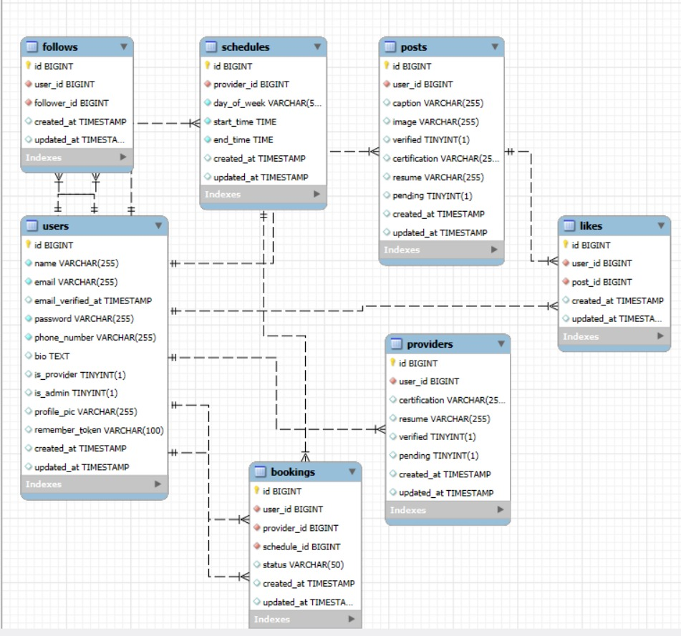

## 2. Subsystem Decomposition:

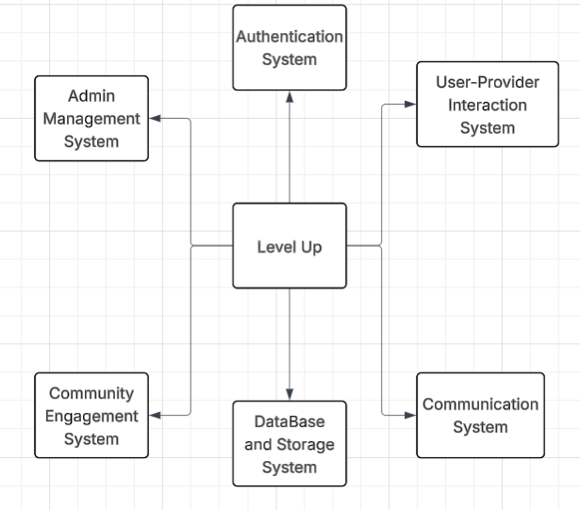

## 3.Sequence:

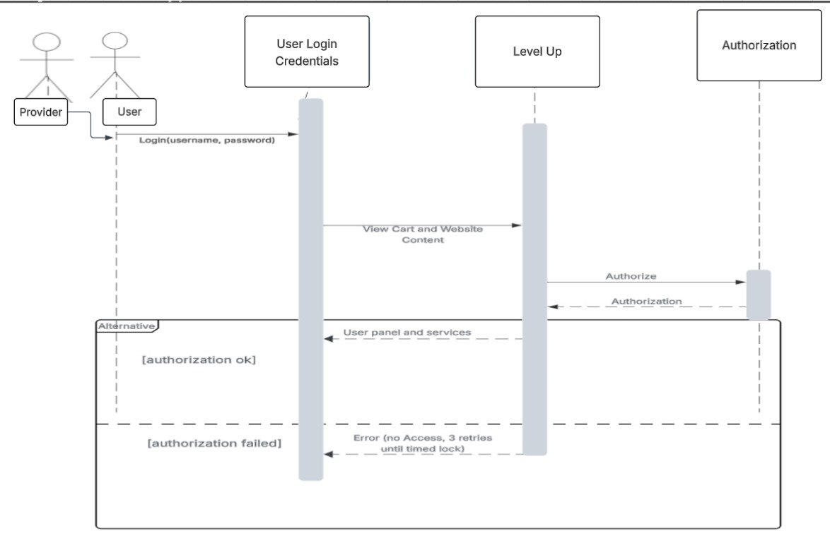

4.Interaction Models:

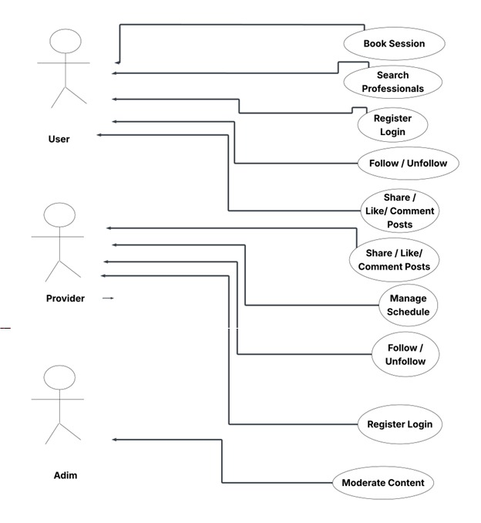

# Test Plans

**Features to Be Tested**

* User registration, login, and role assignment (user / professional / admin)
* Professional profile creation and verification
* Session booking system (availability display, appointment confirmation, cancellation)
* Payment processing via Stripe/PayPal
* Chat system and video conferencing integration
* Community features (posts, comments, moderation)
* Admin tools for content and user management

**Features Not to Be Tested**

* Third-party platform functionality itself (Zoom, PayPal reliability)
* External hardware performance (user devices, network speed not under project control)

**Pass/Fail Criteria**

* **Pass:** A feature passes if it meets all functional requirements, without critical bugs, under normal conditions.
* **Fail:** A feature fails if:
  + The expected outcome is not achieved
  + Critical bugs are present (e.g., crash, incorrect payment)
  + Performance drops below defined thresholds (like >2-second loading time)

**Approach**

* **Unit Testing:** Each component (login, booking, payment) will be tested independently.
* **Integration Testing:** Ensure smooth interactions between components (e.g., booking + payment).
* **System Testing:** Full user flows from registration to booking and payment will be tested.
* **Acceptance Testing:** Validate the system against user requirements.

Testing will be manual and iterative. Feedback from initial users will guide adjustments.

**Suspension and Resumption**

* **Suspend Testing If:**
  + Core functionalities like authentication or payment APIs are non-functional
  + Major server or database failure occurs
* **Resume Testing When:**
  + Core issues are resolved
  + Stable environment is available

**Testing Materials (Hardware/Software Requirements)**

* **Hardware:** Standard laptops, desktops, smartphones (iOS/Android)
* **Software:**
  + Browsers: Chrome, Firefox, Safari
  + Backend: Laravel 11 environment
  + Database: MySQL
  + Video API (Zoom/Google Meet) test accounts
  + Payment API (Stripe/PayPal) sandbox environments

**Test Cases (Examples)**

| **Test Case** | **Description** | **Expected Result** | **Pass/Fail** |
| --- | --- | --- | --- |
| User Sign-Up | New user registration | Successful account creation |  |
| Professional Verification | Admin approves professional | Status updated to verified |  |
| Booking Session | User books an appointment | Appointment appears in schedules |  |
| Payment | User pays for a session | Payment processed, receipt generated |  |
| Post in Community | User uploads a post | Post is visible in community section |  |
| Admin Moderation | Admin deletes inappropriate content | Content removed successfully |  |
| Chat System | User chats with professional | Messages sent and received correctly |  |

**Testing Schedule**

| **Week** | **Activities** |
| --- | --- |
| Week 1-2 | Unit testing for authentication and role management |
| Week 3-5 | Test booking system (availability, confirmation, rescheduling) |
| Week 6-8 | Test payment processing and refund handling |
| Week 9-10 | Community posts and moderation testing |
| Week 11 | Full system integration and stress testing (simulate multiple users) |
| Week 12 | Final acceptance testing, bug fixing, and polishing |

# Implementation

Home

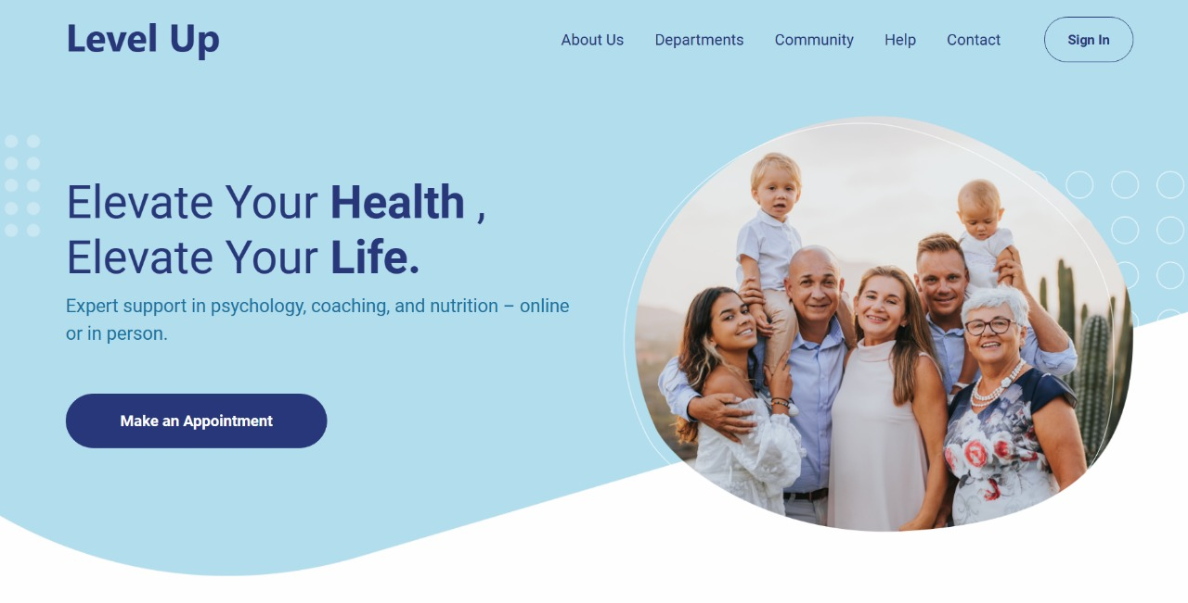

Approve provider :

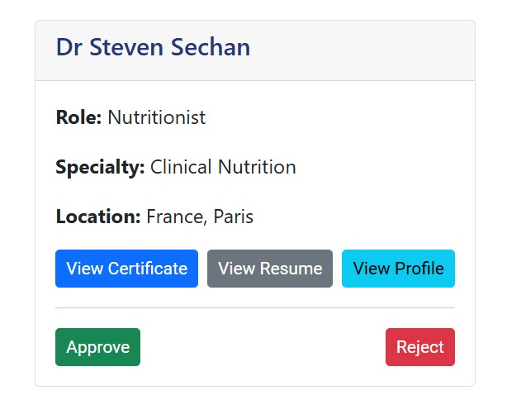

Provider register

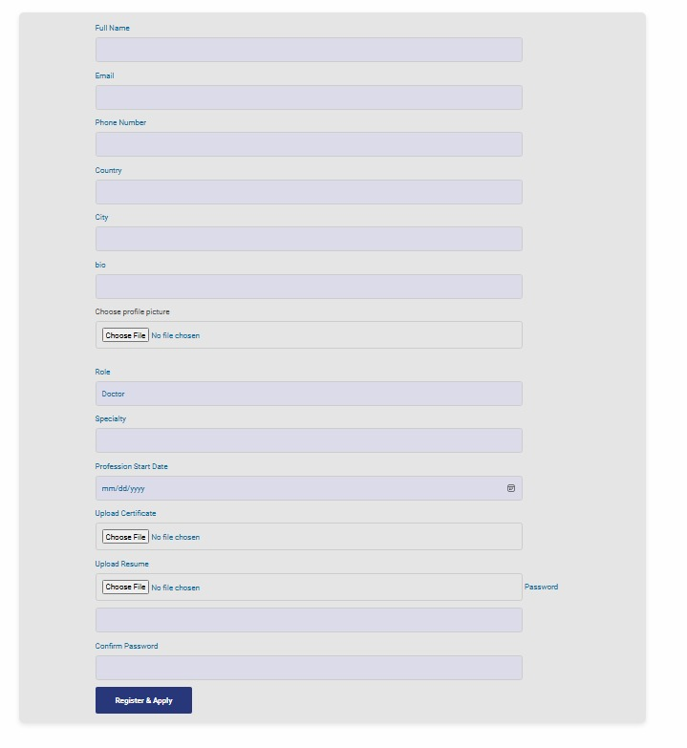

‘

Doctor profile

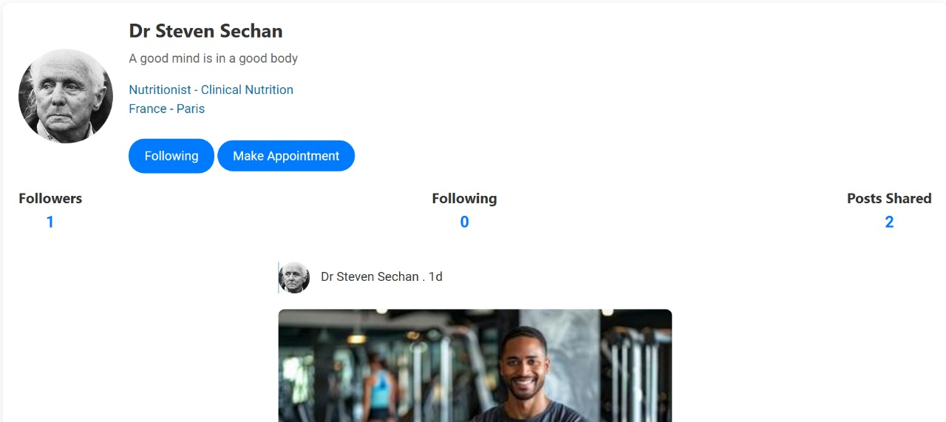

Doctor post (community):

Set free time :

Booking time :

User sign in:

Booking status:





Upload post on community:

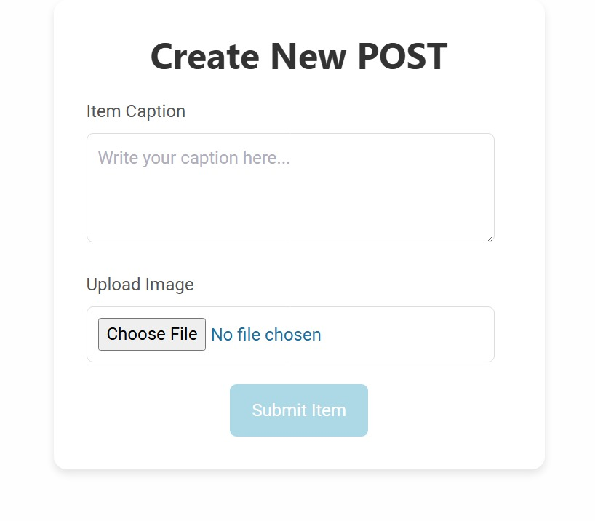

# Results Evaluation

The testing phase showed that:

* **Authentication:** Registration, login, role assignment, and password reset functions worked smoothly across devices.
* **Booking System:** Successfully handled appointments, cancellations, and time-slot displays. Minor bugs found in rescheduling were fixed.
* **Payments:** Payments through Stripe and PayPal processed correctly in sandbox mode. Refund policy logic worked as intended.
* **Community Module:** Users could post, like, and comment without crashes. Admin moderation tools were effective.
* **Chat and Video Integration:** Chat worked perfectly. Video sessions sometimes had minor connection delays due to external Zoom/Google Meet issues.
* **Performance:** Page loading stayed under 2 seconds on average. The platform was usable even under simulated 100 concurrent users.
* **Security:** HTTPS encryption and role-based access were correctly implemented.
* **Responsiveness:** All critical functionalities worked correctly across mobile and desktop devices.

# Conclusion

## Summary

The Level Up platform is designed to meet the growing need for holistic health solutions by providing connections between users and certified professionals in fitness, nutrition, and mental well-being through a single integrated web experience. It allows users to book sessions, track progress, engage with a supportive community, and contribute to social causes. The platform will be built on Laravel 11, MySQL, Blade, and Vue.js, assuring a secure, scalable, and easy-to-use environment. Phased development will ensure the timely incorporation of features important for the successful launch, in 12 weeks, such as authentication, booking, payments, and community support.

## Novelty

Level Up distinguishes itself from existing platforms through the combination of personalized health services with serious community involvement and charitable initiatives, all in one centralized system. In contrast to platforms that focus solely on one health component, Level Up integrates fitness, nutrition, and mental wellness and adds features such as AI recommendation, multilingual support (Arabic, English, and French), and telehealth capabilities. It is this integrated model that fulfills a significant gap in the Lebanese and regional markets, offering users an all-encompassing and culturally relevant platform.

## Integrity and Values

Project is built on a foundation of trust, an inclusive, and ethical accountability. It raises the user's trust level with a transparent display of professional credentials. The data security, privacy, and compliance of an international regulation like GDPR are prioritized to secure sensitive user data. Standards of accessibility shelter that the platform can be accessed by people with disabilities. And it's embedding all community values of fairness, mutual support, and respect in each feature, setting out to affect an all-round positive, empowering environment for all users.

## Future Work

Looking ahead, Level Up plans to expand its offerings by incorporating AI-powered personalized service suggestions, also the approval of doctors will be automated, launching a mobile application, and supporting additional professional categories such as physiotherapists and life coaches. Further enhancements could include advanced health tracking integrations (e.g., wearables), multilingual expansion into other markets, and deeper analytics for user progress and engagement. Continuous user feedback will guide platform evolution, ensuring Level Up remains adaptive, impactful, and a leader in holistic health innovation.

# References / Bibliography

: Cite all ideas, concepts, text, data that are not your own. If you make a statement, back it up with your own data or a reference. All references cited in the text must be listed. There are two main ways to cite a reference within a text:

Citing the reference by author’s name: the author’s name must be placed at the end of the sentence that is taken from that reference along with the year of publication, then in the reference section the author’s name is to be arranged in alphabetical order.

Citing the reference by numbers: you should start numbering from 1 and continue according to order of appearance in text. Numbers should be placed the end of the sentence that is taken from that reference, then in the reference section you start your reference list from number 1.

You are recommended to use the APA writing style, which cites the reference by the author’s name, in your references’ citations.

The first line of each entry in your reference list should be on the left margin. Subsequent lines should be indented five spaces from the margin. All references should be double-spaced. Capitalize only the first word of a title or subtitle of a work. Italicize titles of books and journals. Note that the italicizing in these entries often continues

beneath commas and periods. Each entry is separated from the next by a double space (thus the entire reference list is double spaced, with no extra returns added).

Authors' names are inverted (last name first); give last name and initials for all authors of a particular work. Your reference list should be alphabetized by authors' last names. If you have more than one work by a particular author, order them by publication date, oldest to newest (thus a 1991 article would appear before a 1996 article). When an author appears as a sole author and as the first author of a group, list the one-author entries first. If no author is given for a particular source, alphabetize by the title of the piece and use a shortened version of the title for parenthetical citations. Use "&" instead of “and” on the reference page and only within parentheses when citing multiple authors of a single work in your text. At the end of the project list all references cited in the text in alphabetical order.

For an article in a journal:

***Author, A. A., Author, B. B., & Author, C. C. (Year of Publication). Title of article. Title of periodical, Volume Number, pages.***

Example 1: Harlow, H. F. (1983). Fundamentals for preparing psychology journal articles. Journal of Comparative and Physiological Psychology, 55, 893-896.

Example 2: Kernis, M. H., Cornell, D. P., Sun, C. R., Berry, A., & Harlow, T. (1993). There's more to self-esteem than whether it is high or low: The importance of stability of self-esteem. Journal of Personality and Social Psychology, 65, 1190-1204.

For a chapter in a book:

***Author, A. A., & Author, B. B. (Year of Publication). Title of chapter. In A. Editor &***

B. Editor (Eds.), Title of book (pages of chapter). Location: Publisher. When you list the pages of the chapter or essay in parentheses after the book title, use "pp." before the numbers: (pp. 1-21).

Example: O'Neil, J. M., & Egan, J. (1992). Men's and women's gender role journeys: Metaphor for healing, transition, and transformation. In B. R. Wainrib (Ed.), Gender issues across the life cycle (pp. 107-123). New York: Springer.

For a web page:

***Author, A. A., & Author, B. B. (Date of Publication or Revision). Title of full work [online]. Retrieved month, day, year, from source Web site: URL.***

Example: Chou, L., McClintock, R., Moretti, F. & Nix, D. H. (1993.) Technology and education: New wine in new bottles: Choosing pasts and imagining educational futures. Retrieved August 24, 2000, from Columbia University Institute for Learning Technologies Web site: <http://www.ilt.columbia.edu/publications/papers/newwine1.html>

For an online journal:

***Author, A. A., & Author, B. B. (Date of Publication). Title of article. Title of periodical, xx, xxx-xxx. Retrieved month, day, year, from URL.***

Example: Frederickson, B. L. (2000, March 7). Cultivating positive emotions to optimize health and well-being. Prevention &Treatment, 3 Article 001a. Retrieved November 20, 2000, from <http://journals.apa.org/prevention/volume3/pre0030001a.html>

# Appendix

Glossary

Naming Conventions and Definitions

Code and links

User Manual